CR-Code Black ring with white code: JR5X LBNW(JR5X);RBM
Ringing Centre Stavanger Museum (Norway) Ring number 4267588
Species Lesser Black-backed Gull Larus fuscus
Sex Unknown Age Pullus
Date | Place | Coordinates | Observers | Days/km/°
02.08 2012 | Kvannholmen Auvær, Tromsø, Troms, Norway | 69°52'20"N 018°02'34"E | Helberg, Morten  Olsen, Knut Sigbjørn | -
13.01 2013 | Comenar Viejo, Madrid, Spain | 40°15'41"N 003°38'00"W | Gonzalez, Delfin  Juan, Miguel | 164/3525/211
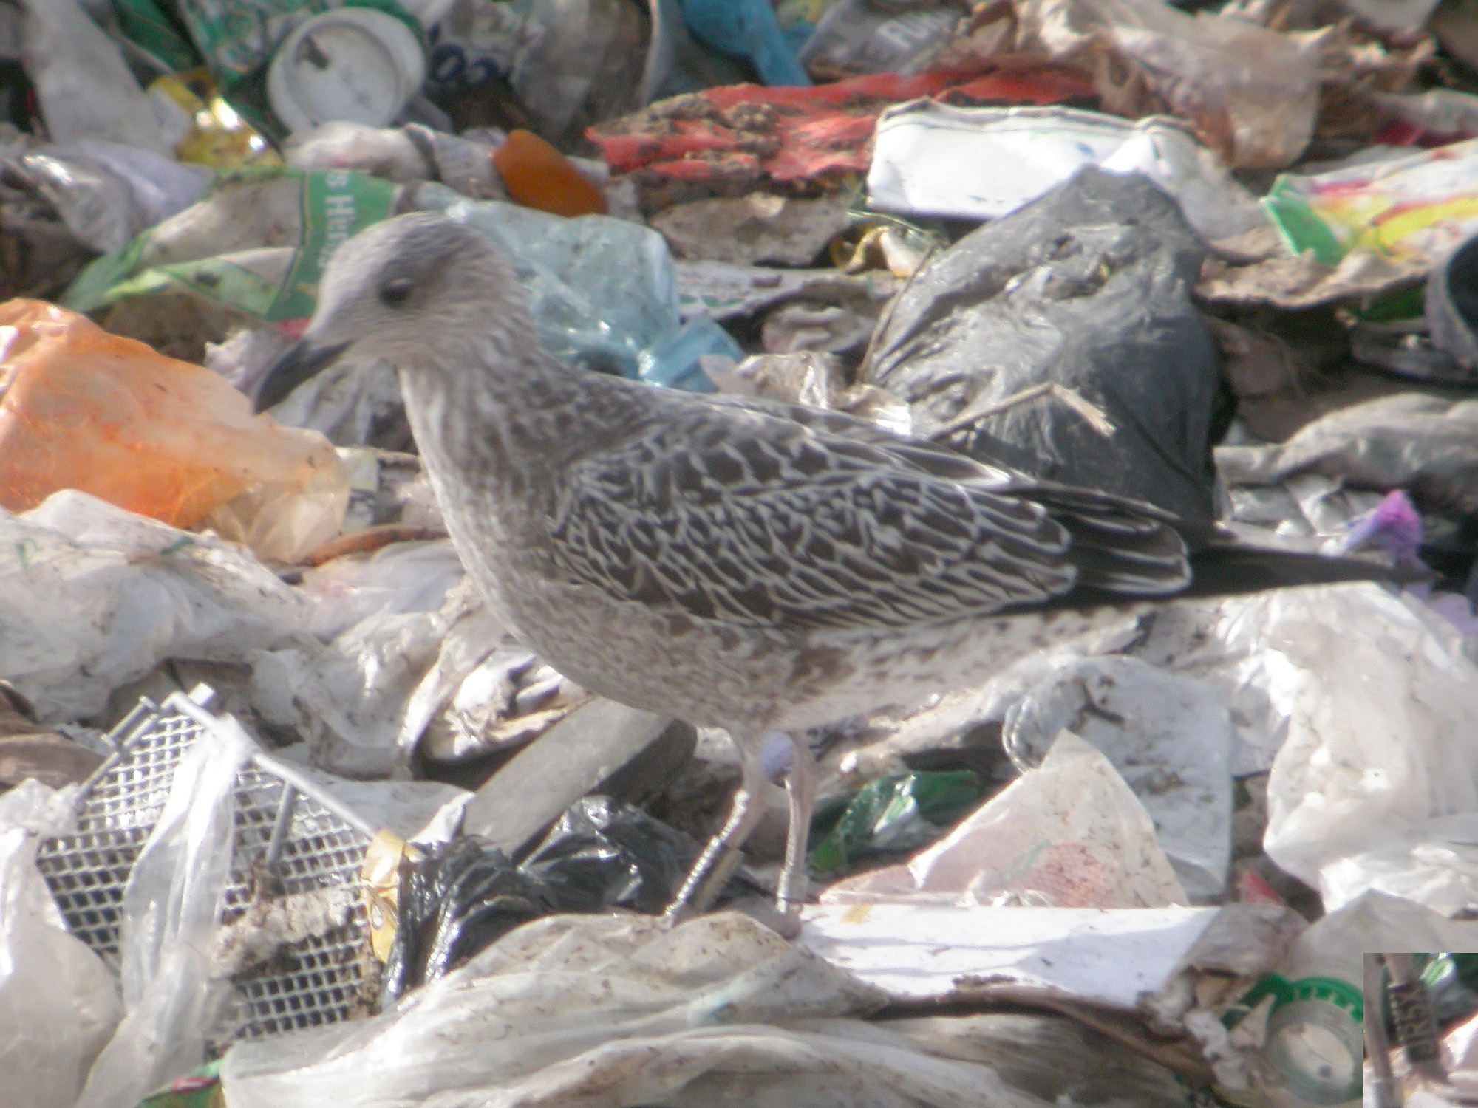
VRSU de Colmenar. 13-1-2013

